24-25 Lesson Plan Template Teacher: STOKES/HARRIS Subject: ENG PREP 2

 | Monday  April 7  Fiction |  | Tuesday  April 8  Fiction | Wednes/Thurs (Block days)  April 9/10  Fiction | Friday  April 11  Fiction
Knowledge Objective | Students will examine the allure and impact of fear on decision-making in historical and modern settings.
TEKS | Priority TEKS:  ELA.10.6.B analyze how authors develop complex yet believable characters,  including archetypes, through historical and  cultural settings and events (R)  ELA.10.4.F make inferences and use evidence to support understanding (R) |  | Priority TEKS: ELA.10.6.C analyze  isolated scenes and their contribution to the success of the plot as a  whole (R)  ELA.10.4.F make inferences and use evidence to support understanding (R) | Priority TEKS:  ELA.10.8.D analyze how the author's use of language informs and  shapes the perception of readers (R)  ELA.10.8.F analyze how the author's diction and syntax contribute to the ​​mood, voice, and tone of a text (R) | ELA.10.8.A analyze the  author’s purpose, audience,  and message within a text  (R)  ELA.10.5.D paraphrase and  summarize texts in ways  that maintain meaning and  logical order (R)  ELA.10.4.G evaluate details  read to determine key ideas  (R)
LO | SWBAT analyze development of complex characters and make  inferences supported by textual evidence. |  | SWBAT analyze how isolated scenes influence the overall plot and make inferences supported by textual evidence. | SWBAT analyze how the  author’s language shapes  the reader's perceptions and  contributes to the mood and  tone of the text.  SWBAT make inferences to support understanding and evaluate details to  determine key ideas. | SWBAT analyze the  author’s purpose, clear  thesis, relevant supporting  details, organizational  design, and evaluate details to summarize the text accurately.
HOT  Qs | How does inner conflict contribute to a character’s complexity? |  | Is the climactic scene of a short story always the scene that has the most influence over the whole plot? | How do archetypal characters reflect real-life stereotypes or relate to people’s personal lives? | How does the author’s purpose, in writing a story, relate to the author’s background and experiences?
Genre | Short Story Fiction |  | Short Story Fiction | Short Story Fiction | Short Story Fiction
Agenda | Do Now: Ss read the opening paragraph of “Home to El Building” by Judith Ortiz Cofer  The best time to run away from home is noon, Anita thinks, because nobody’ll notice you walking away from your life in the blinding sunlight while they eat their pork sandwiches at the counter in Cheo’s bodega, or while they fold their laundry at La Washeteria, or come out of  their dark apartments, a hand over their eyes, as in a salute, because the cement reflects the white-hot July sun and gives you an instant headache when it first hits you.  and answer:  Based on the text, Anita is a character who is  (check 1 box)  - perceptive and desperate  - careful and thoughtful  - perceptive and observant  Cite the text evidence to support your answer:_____________.  Mini lesson: T shows an introduction slide which talks about the author and background for the text. Also T review anchor chart for characterization (dynamic character).  Guided practice *MRS**:  Board’s up for pages 1-3. Ss scan text to find the answer. I minute each  Round one: What does Anita dislike about her barrio (or neighborhood)?  Anita dislikes that people only speak Spanish and live like they are in a tropical country, and her friends are childish or trying to “self-destruct” on drugs.  Round two: Fill in the blank  Anita is both in ____ with and wants a ____ from Frank.  Anita is both in love with and wants a job from Frank.  Round three:  How is Frank different from Anita?  Frank is Italian, while Anita is Puerto Rican. Frank is 10 yrs older than Anita.  HOT Turn and Talk question: Why does Frank and his environment seem better than Anita’s own, even though he has immigrant parents and lives in an inner-city ethic block like she does?  Independent practice:.  Students summarize the sequence of events to “Home to El Building” by completing the following sentences as they read the rest of the story.  - Anita’s parents have been fighting for ___ ________.  - Anita meets___________and leaves her name and _________ to apply for a _________.  - Frank __________Anita and __________ her the next day  - After ___month, Franks tells Anita she can __________ with him.  - Anita decides to ________ away, ________ with Frank, and ______ ___ of school.  - Mirta warns Anita about_____________.  - Through the window, Anita watches Frank ______ _____ ___ ______ and she ________ ________.  - Anita _______________ Francesco’s Deli and goes back to _________________, rejecting _______________ and escaping “_______________.”  Optional activity: time permitted| Place the events in order and then show what trait is revealed by Anita’s action or reaction. *a STEAL character analysis may also be done*  Sequence of events Write the events correctly from 1st to last. *the first is done for you* Anita’s character trait shown in this event?  Event 1 Anita meets Frank while she’s leaving her name and address in application for a job at Frank’s bodega. This shows Anita as a planner; she takes initiative  Event 2  Event 3  Event 4  Event 5  Event 6  DOL: SCR Prompt using RACE: How is Anita a dynamic character (How does she change over the course of the story?) in “Home to El Building”? |  | Do Now: Pick up “Home to El Building” text and refresh your knowledge of the text. Answer: How was Anita wrong about her neighborhood and about Frank?  Guided practice:  Ss may finish previous DOL extension:  Optional activity: time permitted| Place the events in order and then show what trait is revealed by Anita’s action or reaction. *a STEAL character analysis may also be done*  Sequence of events Write the events correctly from 1st to last. *the first is done for you* Anita’s character trait shown in this event?  Event 1 Anita meets Frank while she’s leaving her name and address in application for a job at Frank’s bodega. This shows Anita as a planner; she takes initiative  Event 2  Event 3  Event 4  Event 5  Event 6  Independent practice:  Ss reread and excerpt from “Home to El Building” and answer  7 multiple choice questions  DOL:  8-10min  Prep questions to discuss “Home to El Building” for Socratic Seminar  Prep Questions  1. Archetypes: Look at the archetype chart and explain what each character represents. Explain why.  2. In “Home to El Building,” does Anita conclude that Frank is a deceiver? (Does she see the wrong in how she has acted with Frank? How does Mirta and her own parents’ relationship help shape her ending opinion of Frank?) Explain using evidence from the text.  3. What do you think was Judith Ortiz Cofer’s purpose in writing “Home to El Building”? Explain and use evidence from the text.  4. How do the descriptions of languages (Spanish, Italian and English) shape the reader's perceptions about the neighborhoods in “Home to El Building”? How do the descriptions of languages (Spanish, Italian and English) contribute to the tone or mood of the story? Explain. Use text evidence. | Do Now: Take out Prep questions and highlight text evidence to back up your answers (in prep for Socratic seminar).  Mini lesson: T goes over sentence stems students may use during socratic seminar discussion  Socratic Seminar  15 minutes *this may be adjusted*  DOL1  Each group (divide the class into 3) speaks in a fishbowl discussion for 5 minutes.  Prep Questions  1. Archetypes: Look at the archetype chart and explain what each character represents. Explain why.  2. In “Home to El Building,” does Anita conclude that Frank is a deceiver? (Does she see the wrong in how she has acted with Frank? How does Mirta and her own parents’ relationship help shape her ending opinion of Frank?) Explain using evidence from the text.  3. What do you think was Judith Ortiz Cofer’s purpose in writing “Home to El Building”? Explain and use evidence from the text.  4. How do the descriptions of languages (Spanish, Italian and English) shape the reader's perceptions about the neighborhoods in “Home to El Building”? How do the descriptions of languages (Spanish, Italian and English) contribute to the tone or mood of the story? Explain. Use text evidence.  DOL2  Ss write a reflection paragraph about  - How did the socratic discussion help your understanding of the text?  - What further questions do you have about the author or the story? | Do Now: Write about a time you spent with a relative or a friend. What did you talk about? How did you feel about the situation?  Mini lesson: preview vocabulary    Guided practice *MRS**:  Before students read  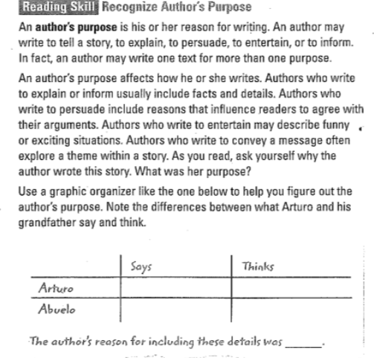  Ss table read or listen to (in chunks) “An Hour with Abuelo”  Guided questions (LOOK FORS): Ss answer the questions in the right margin as they read.  DOL  Extended short answer Qs    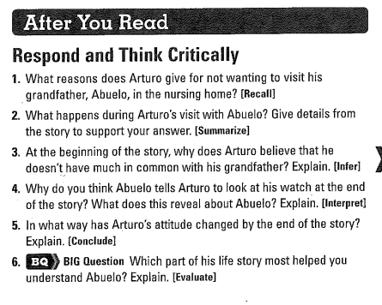
DOL | Given a text, analyze how authors  develop complex characters  through cultural settings, by composing an SCR,  with 80% accuracy. |  | Given a text, analyze how isolated scenes and cultural settings influence the overall plot  and make inferences supported by textual evidence, by preparing for Socratic discussion w/prep questions, with 80%  accuracy. | Given a text,  - analyze how the author’s  language shapes the reader's perceptions and contributes to the mood and tone of the text,by performing and reflecting on Socratic discussion, with 80%  accuracy.  - make inferences to  support understanding and evaluate details to determine key ideas, by performing and reflecting on Socratic discussion, with 80% accuracy. | Given a text, analyze the author’s purpose, clear thesis, relevant supporting  details, organizational  design, and evaluate details to summarize the text accurately, by answering extended short answer questions, with 80% accuracy.
 | Anchor text:  “Home to El Building” by Judith Ortiz Cofer  Slides: https://www.canva.com/design/DAGjrkERlBg/uwtV1nkBojV9P423aPOf5w/view?utm_content=DAGjrkERlBg&utm_campaign=designshare&utm_medium=link2&utm_source=uniquelinks&utlId=h94c044bbc1 |  | Anchor text:  “Home to El Building” by Judith Ortiz Cofer  Slides: https://www.canva.com/design/DAGjrkERlBg/uwtV1nkBojV9P423aPOf5w/view?utm_content=DAGjrkERlBg&utm_campaign=designshare&utm_medium=link2&utm_source=uniquelinks&utlId=h94c044bbc1 | Anchor Text  Slides: https://www.canva.com/design/DAGjrkERlBg/uwtV1nkBojV9P423aPOf5w/view?utm_content=DAGjrkERlBg&utm_campaign=designshare&utm_medium=link2&utm_source=uniquelinks&utlId=h94c044bbc1 | Texts  Slides: https://www.canva.com/design/DAGjrkERlBg/uwtV1nkBojV9P423aPOf5w/view?utm_content=DAGjrkERlBg&utm_campaign=designshare&utm_medium=link2&utm_source=uniquelinks&utlId=h94c044bbc1

